**Enhancing Safety and Compliance: The Role of Instant Narcotic Wipes in DOT Trucking Companies**

In the highly regulated world of DOT trucking, maintaining a drug-free workplace is not just a matter of policy—it's a critical public safety and compliance issue. Employers face unique challenges in ensuring that their drivers and other personnel adhere to the stringent drug-free regulations set by the Department of Transportation. Trace Eye-D’s instant narcotic detection wipes offer an efficient and reliable solution to help trucking companies enhance safety and ensure compliance with federal guidelines.

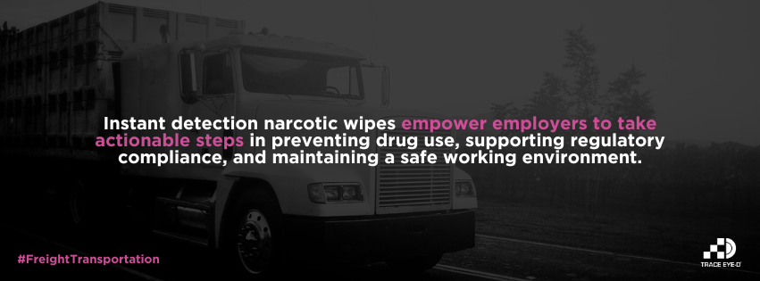

**Rapid Detection for Immediate Action**

Trace Eye-D's instant detection wipes enable employers to conduct quick and effective checks for the presence of narcotics such as fentanyl, cocaine, and methamphetamines. With the simple **Open, Wipe, Look** (OWL) method, supervisors can swiftly test surfaces, personal belongings, or even residues within vehicles. This immediate detection capability is crucial in a fast-paced environment where the safety of the driver and the public depends on swift decision-making.

**Preventive Measures for Safety**

Utilizing Trace Eye-D wipes can serve as a powerful preventive measure. Regular checks using these wipes can deter the use of illicit substances among employees, thereby fostering a culture of safety and responsibility. For trucking companies, where the consequences of drug use can be particularly severe, such proactive measures are invaluable. They not only protect the company's assets and reputation but also safeguard the lives of employees and the general public.

**Supporting Compliance and Documentation**

Adherence to DOT regulations is a non-negotiable aspect of the trucking industry. Trace Eye-D wipes not only help in maintaining compliance with these regulations but also provide documentation of the company's efforts to maintain a drug-free workplace. This documentation can be critical during audits and inspections, providing evidence of the company’s dedication to regulatory compliance and safety.

**Creating a Healthier Work Environment**

The use of Trace Eye-D’s narcotic detection wipes contributes to a healthier work environment. By ensuring that work areas and vehicles are free of narcotics, employers help reduce the risk of accidents and enhance the overall wellbeing of their employees. This commitment to a safe and healthy workplace can also boost employee morale and aid in retention by demonstrating the company’s commitment to their safety and health.

For **DOT trucking companies**, Trace Eye-D's instant narcotic detection wipes are not just tools, but integral components of their safety and compliance strategies. These wipes empower employers to take actionable steps in preventing drug use, supporting regulatory compliance, and maintaining a safe working environment. Embracing this technology reflects a forward-thinking approach to workplace safety and underscores a commitment to upholding the highest standards of the trucking industry.