**Five Benefits to Correctional Facilities Using Trace Eye-D Instant Detection Narcotic Wipes**

Ensuring **CORRECTIONAL FACILITIES** are stocked with instant detection narcotic wipes, empowers correctional officers to address the unique challenges and dangers they face on a daily basis, promoting safety, compliance, and rehabilitation within the facility for the benefit of both staff and inmates.

1. ***Enhanced Safety and Security:*** In the high-stakes environment of correctional facilities, maintaining safety and security is paramount. Instant detection narcotic wipes provide correctional officers with a powerful tool to quickly and effectively detect the presence of illicit drugs among inmates, helping to prevent drug-related incidents, violence, and contraband trafficking within the facility.
2. ***Proactive Contraband Detection:*** Contraband poses a significant threat to the safety and order of correctional facilities, with drugs being one of the most common and dangerous types of contraband. By incorporating instant detection narcotic wipes into their toolkit, correctional facilities can proactively identify and confiscate illicit drugs, deterring drug use and trafficking among inmates and reducing the associated risks of addiction, overdose, and violence.

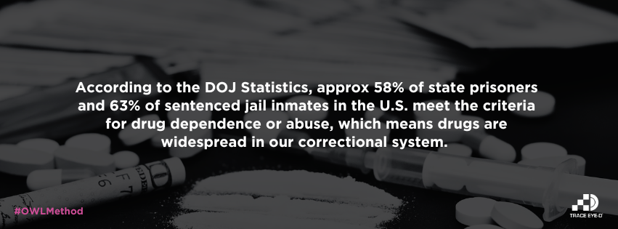

1. ***Compliance with Regulations:*** Correctional facilities are subject to strict regulations and standards governing inmate welfare, safety, and security. By utilizing instant detection narcotic wipes, correctional officers can demonstrate compliance with mandated drug detection protocols and ensure that inmates are housed in a drug-free environment, safeguarding their health and well-being.
2. ***Early Intervention and Treatment:*** Detecting drug use among inmates early on is critical for addressing underlying issues, preventing escalation, and promoting rehabilitation. Instant detection narcotic wipes enable correctional officers to identify individuals struggling with substance abuse and connect them with the necessary support services, including counseling, treatment programs, and medical care, to facilitate recovery and reduce recidivism.
3. ***Improved Inmate Safety and Well-Being:*** Inmate safety is a top priority for correctional facilities, and drug use poses significant risks to the health and well-being of inmates. By effectively detecting and addressing drug use with instant detection narcotic wipes, correctional officers can create a safer and healthier environment for inmates, reducing the prevalence of drug-related incidents, medical emergencies, and the spread of infectious diseases within the facility.

_________________________________________________________________________________