**Five Ways School + University Campuses Can Benefit from Trace Eye-D Instant Narcotic Detection Wipes**

Keeping students safe is a priority for every educational institution. Trace Eye-D’s instant narcotic detection wipes, with the #OWLmethod—Open. Wipe. Look.—provide fast, reliable results. Here’s why these wipes are essential for school and university campuses.

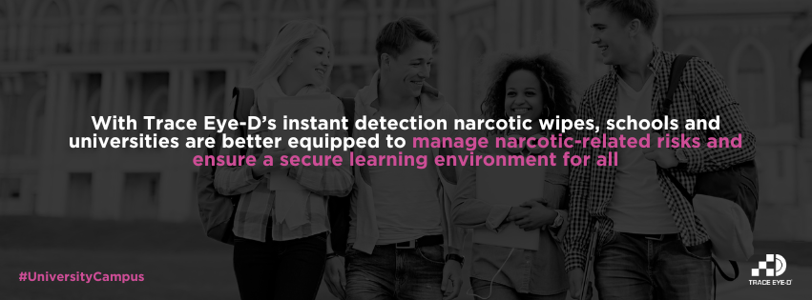

### **1. Instant Results, Enhanced Campus Safety**

Get quick, actionable results to ensure campus safety in real-time.

### **2. Simple and Effective Detection Process**

The #OWLmethod makes detection as easy as Open. Wipe. Look.—no extensive training needed.

### **3. Minimizing Risk of Exposure for Staff and Students**

One-use wipes reduce handling risks, protecting both staff and students.

### **4. Supporting Drug Awareness and Prevention Programs**

Show a proactive stance on student safety and well-being.

### **5. Cost-Effective Tool for On-the-Spot Screening**

Portable and affordable, these wipes make campus-wide checks feasible and efficient.

**Empower Your Campus with Instant Detection**

Educational institutions can proactively enhance campus safety with Trace Eye-D’s instant detection wipes. With fast results, a user-friendly approach, and the safety of the #OWLmethod, schools and universities are better equipped to manage narcotic-related risks and ensure a secure learning environment for all.