**Five Ways School + University Campuses Can Benefit from Trace Eye-D Instant Narcotic Detection Wipes**

Keeping students safe is a priority for every educational institution. Trace Eye-D’s instant narcotic detection wipes, with the #OWLmethod—Open. Wipe. Look.—provide fast, reliable results. Here’s why these wipes are essential for school and university campuses.

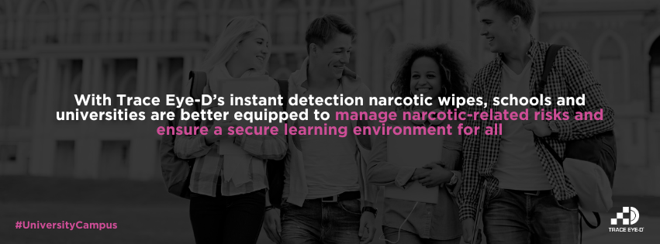

### **1. Instant Results = Enhanced Campus Safety**

### **2. Simple + Effective Detection Process - just Open. Wipe. Look.**

### **3. Minimizing Risk of Exposure for Staff and Students**

### **4. Proactive Stance Supporting Drug Awareness + Prevention Programs**

### **5. Cost-Effective Tool for On-the-Spot Screening**

**Empower Your Campus with Instant Detection**

Educational institutions can proactively enhance campus safety with Trace Eye-D’s instant detection wipes. With fast results, a user-friendly approach, and the safety of the #OWLmethod, schools and universities are better equipped to manage narcotic-related risks and ensure a secure learning environment for all.