**Protecting Our Supply Chain: Why Instant Detection Wipes Are Essential for UPS, FedEx, and USPS.**

In the fast-paced world of shipping and logistics, safety isn’t just a priority—it’s a responsibility. Shipping companies like UPS, FedEx, and USPS must address these dangers proactively to protect their employees, facilities, and customers.

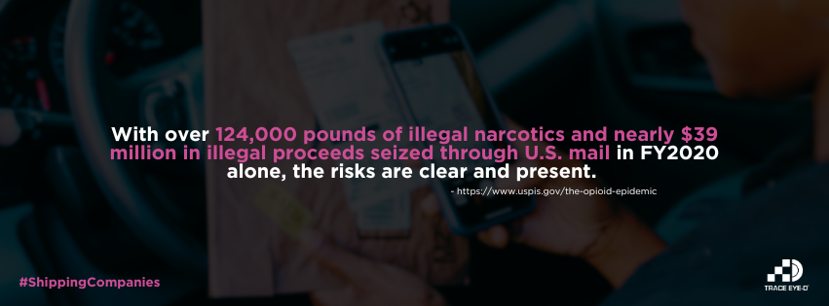

**1. Protecting Employee Health and Safety**Shipping facilities handle millions of packages daily, some of which may contain dangerous substances like narcotics or toxic chemicals. Instant detection wipes provide a fast and reliable way to identify potential threats before exposure occurs, creating a safer environment for employees.

**Key benefits include:**

* Quick detection of harmful substances, such as fentanyl or methamphetamine.
* Reduced risk of accidental contamination or injury during handling.
* Empowering employees with a simple, effective safety tool.

**2. Mitigating Financial and Operational Risks**Encounters with hazardous materials can lead to costly disruptions, legal liabilities, and reputational damage. By using instant detection wipes, companies can prevent such incidents, ensuring smooth operations and reducing financial risk.

**Cost-saving advantages include:**

* Avoiding facility shutdowns due to emergency responses.
* Reducing workers' compensation claims and legal fees.
* Maintaining customer trust by demonstrating a commitment to safety.

**3. Streamlining Risk Management Processes**Traditional detection methods often involve expensive equipment and lengthy procedures. Instant detection wipes are portable, affordable, and integrate seamlessly into daily workflows, enabling faster and more efficient risk management.

**Operational efficiencies include:**

* Eliminating the need for specialized equipment or extensive training.
* Allowing for quick, on-the-spot substance assessments.
* Minimizing disruptions to processing timelines.

**4. Fostering a Culture of Safety**A safe workplace boosts morale and reflects a company’s commitment to its employees and customers. Instant detection wipes help create a secure environment while demonstrating leadership in workplace safety.

By investing in proactive safety measures like instant detection wipes, shipping companies can address the growing risks associated with illegal substances in the mail. To learn more about how Trace Eye-D can help you protect your teams and facilities, visit [Trace Eye-D](https://traceeyed.com/contact-us).