**Why Firefighter Hazmat Teams Should Stock Trace Eye-D Instant Detection Wipes**

Firefighter hazmat teams are the first line of defense in emergencies involving hazardous substances, yet they often face significant challenges with traditional detection methods. Bulky equipment, specialized training, and time delays can hinder response efforts during critical incidents. Trace Eye-D instant detection wipes address these challenges with simplicity, speed, and reliability, making them an essential tool for any hazmat team.

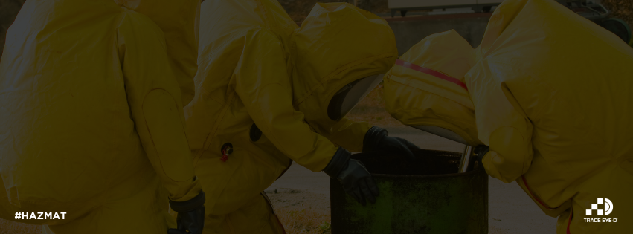

**Rapid Detection for Critical Situations**

Time is of the essence in hazmat responses, where delays can put lives at risk. Traditional methods may require extended processing times or access to specialized labs, slowing down critical decision-making. Trace Eye-D wipes, however, provide instant results with the straightforward #OWLMethod—Open. Wipe. Look.—enabling hazmat teams to identify narcotics, explosives, and other substances in seconds. This rapid response capability is crucial in emergencies where every moment counts.

**Practical Applications in the Field**

Trace Eye-D wipes shine in a variety of real-world scenarios that hazmat teams encounter. For instance:

* **Drug Labs:** Detecting fentanyl residues during drug interdiction efforts ensures that teams can act quickly while minimizing exposure to dangerous narcotics.
* **Explosives at Crime Scenes:** Identifying traces of explosive materials allows teams to determine the presence of threats and assist law enforcement in securing the area.
* **Unknown Powders in Public Spaces:** Testing unidentified substances in public areas, such as transportation hubs or schools, can prevent panic and guide appropriate responses.

These versatile wipes empower hazmat teams to handle a wide range of challenges with confidence and precision.

**Cost-Effective and Easy to Use**

In addition to their practical benefits, Trace Eye-D wipes provide a cost-effective alternative to traditional detection methods. Expensive equipment and the extensive training it often requires can strain budgets and limit readiness. With Trace Eye-D’s single-use wipes, hazmat teams have an affordable, reliable tool that minimizes training requirements while maximizing effectiveness. This ensures that even smaller departments can be equipped to handle complex incidents.

**A Safer and Smarter Solution**

Trace Eye-D instant detection wipes not only enhance operational efficiency but also prioritize safety for first responders. By reducing the need for prolonged handling or exposure to hazardous substances, these wipes help protect hazmat teams during high-stakes missions. Their portability and ease of use make them an indispensable addition to any toolkit.

Whether responding to drug labs, crime scenes, or public emergencies, firefighter hazmat teams can rely on Trace Eye-D wipes for fast, accurate detection that saves time, reduces costs, and enhances safety. With these tools in hand, hazmat teams are better prepared to face the unknown and safeguard their communities.